***Lost in the Sauce***

*SPECIALTY SAUCE SELLER*

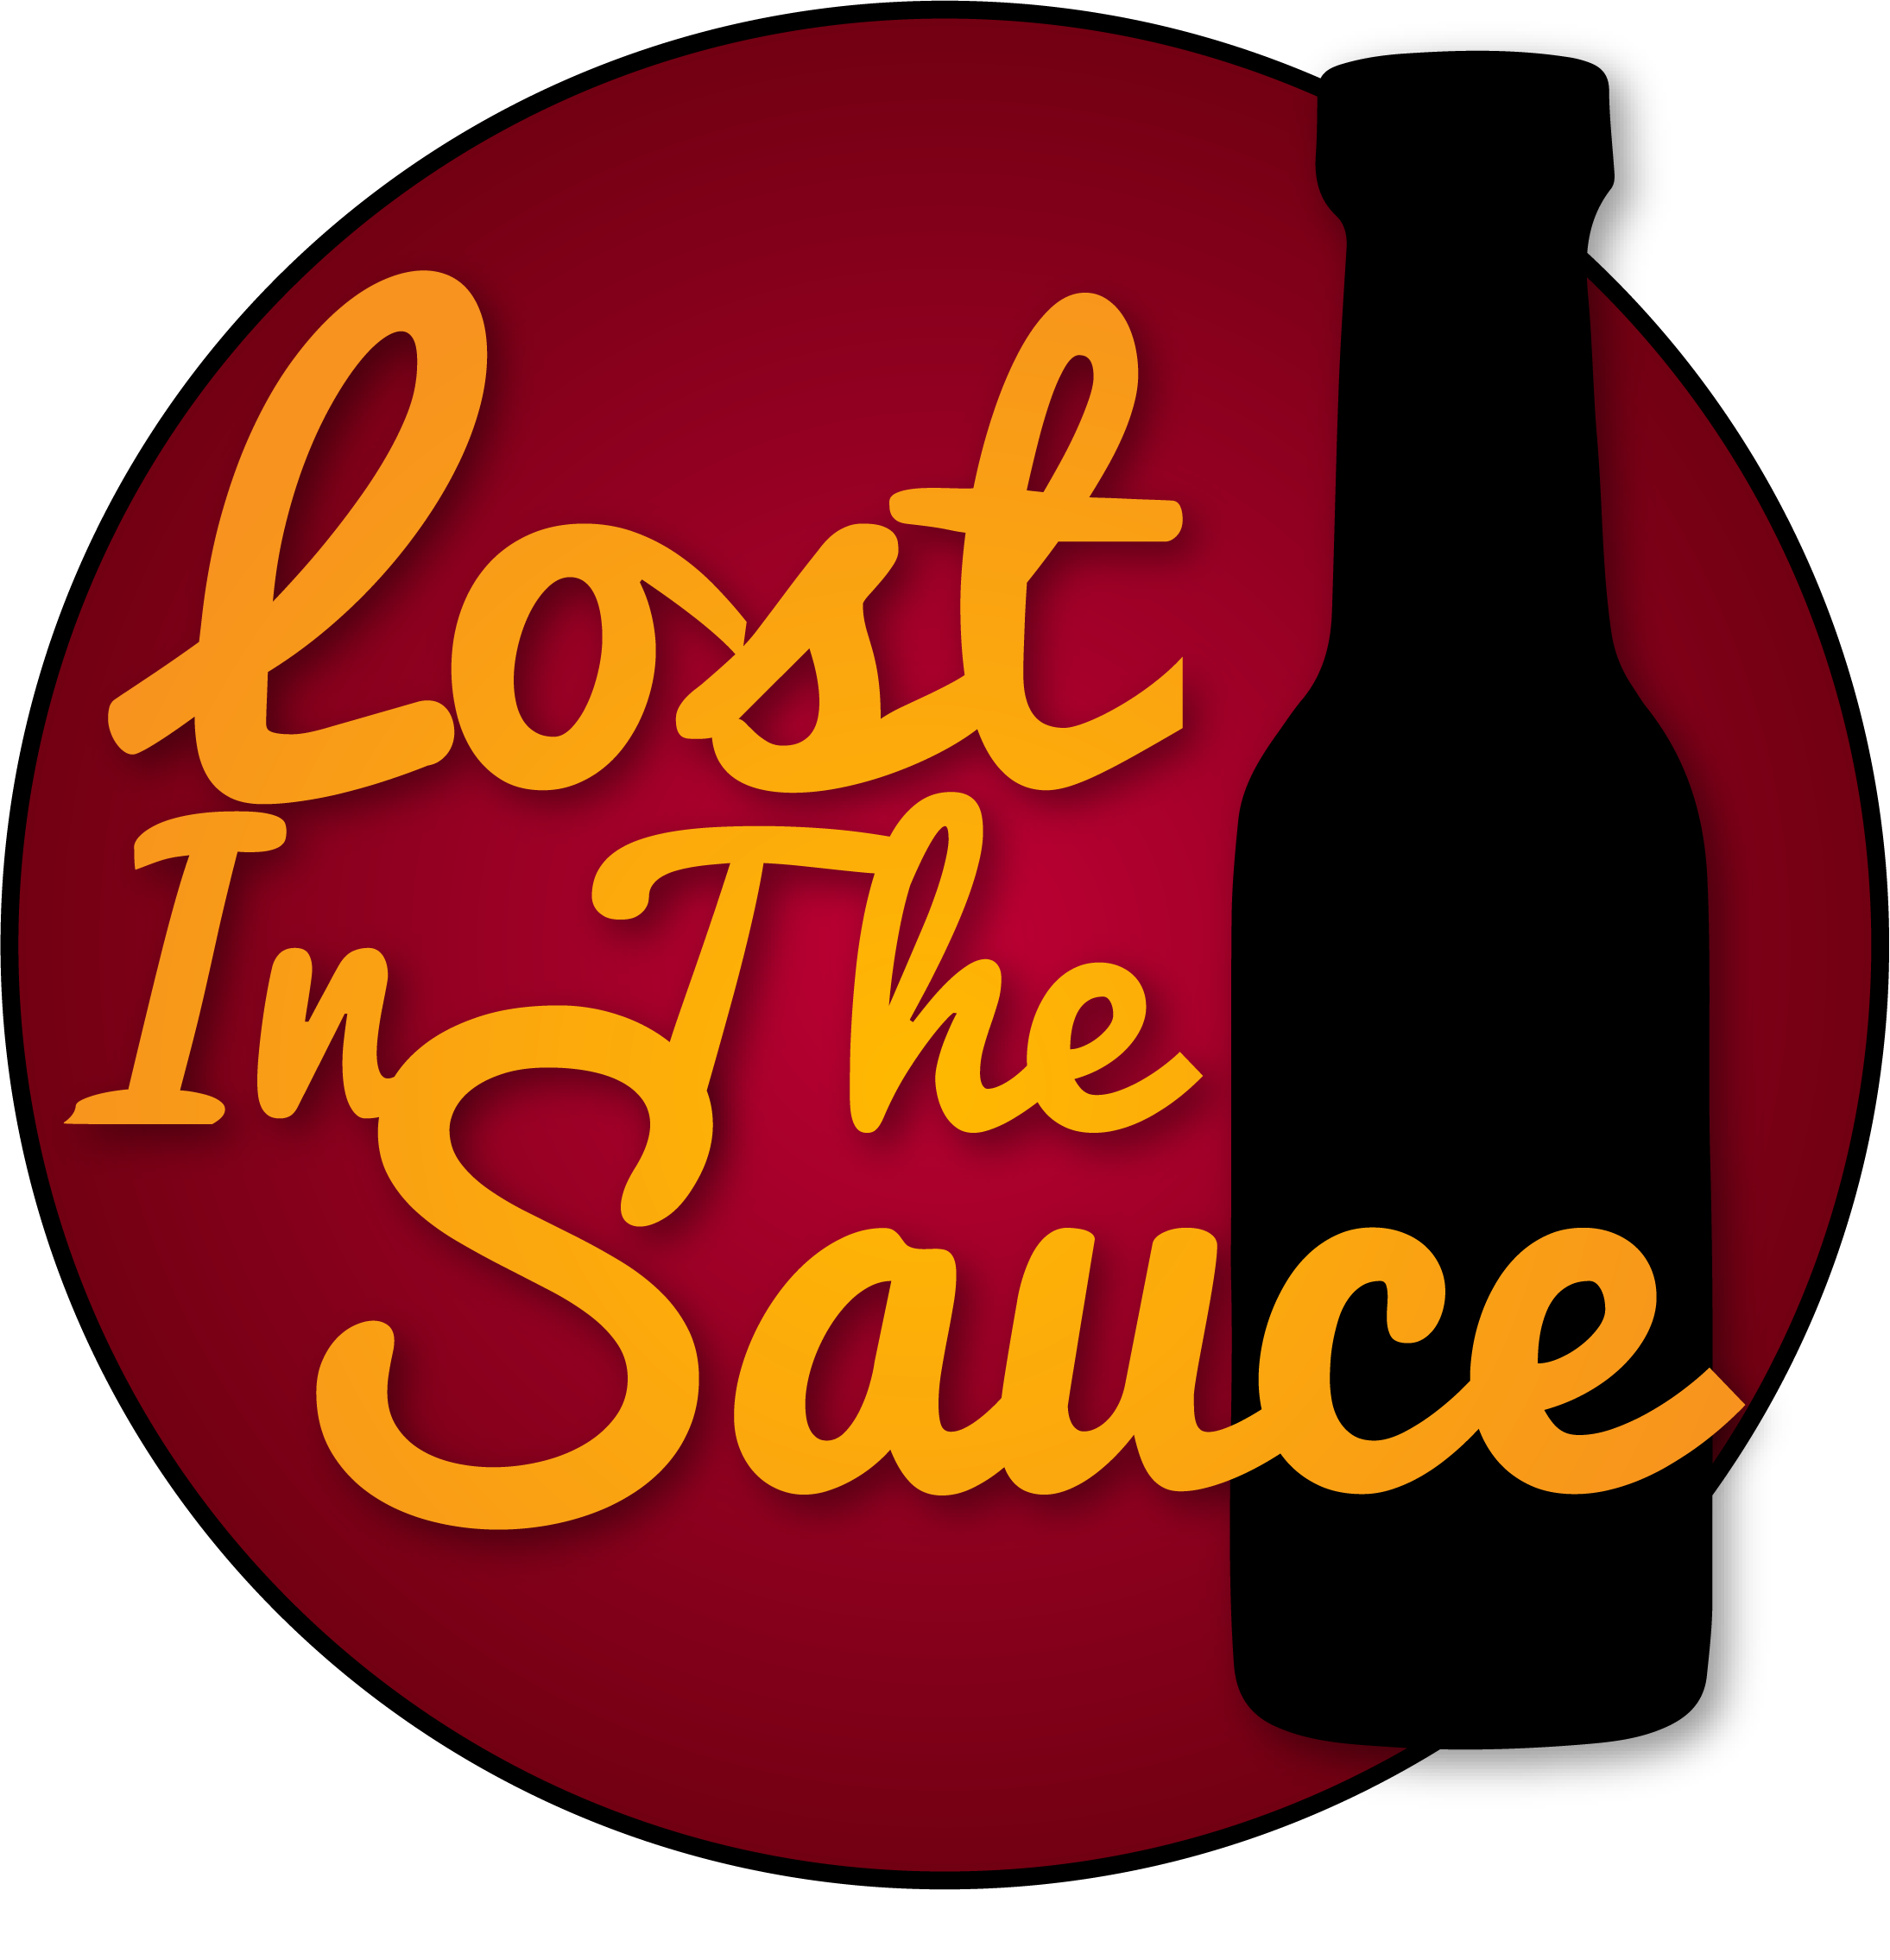

Executive Summary

Statement of Interest

Lost in the Sauce seeks the location within the University of Missouri’s Student Center because Lost in the Sauce is designed to be a business for Mizzou students. Lost in the Sauce was created to be a Mizzou-first company and sees a Mizzou-based location as an essential part of the company’s foundation.

Hours of Operation

Currently, Lost in the Sauce is considering 10:00 AM to 3:00 PM as its hours of operation.

The Product

Lost in the Sauce is a specialty sauce retail shop featuring a wide selection of local, regional and international sauces. The local section includes sauces from local restaurants, farmers and small independent sauce suppliers. The regional section will focus on selling sauces from nearby cities as well as favorite sauces from across the United States. The international section will look at selling the most popular sauces throughout all seven continents. Lost in the Sauce offers a unique brand proposition for manufacturers as we can directly target their sauces to a young market. From Q39 (a KC BBQ sauce) to Thoom (an Arabic garlic sauce), we want to offer college students a taste of home and the world. We want Mizzou to get Lost in the Sauce.

The Market

A specialty sauce store will be a new concept for Columbia as well as the University of Missouri. Lost in the Sauce is positioning itself to cater to a millennial demographic interested in experimenting with new tastes, yet searching for a convenient and time efficient way to do so. Sauces have many advantages for college students: a sauce requires no prep work, has a long-lasting shelf life, is extremely portable and can be added to any dish exactly to the taste of the user. Sauces provide a way for college students to make their cooking taste a little bit more like home. Lost in the Sauce is solving the problem that college students face of not being able to cook flavor-packed meals quickly and affordably. College students want to get Lost in the Sauce.

The Competition

Within the Mizzou campus, the competition for Lost in the Sauce is very slight. In fact, we would encourage campus restaurants and local Columbia restaurants to use our store to sell their individual sauces. Lost in the Sauce would first and foremost be a Mizzou store and would be very interested in selling any local or campus sauces. Outside of campus, our direct competition consists of the A&Y Global Market and upscale grocers such as Lucky’s Market, while our indirect competition consists of all other grocers such as HyVee, Walmart and Aldi’s.

Why Us?

Lost in the Sauce is a specialty store that offers a special consumer experience. Our store will feature sauces that cannot be found at typical grocery stores and will aim to provide a much more personalized relationship with the consumer. Lost in the Sauce will have new sauces being sampled every week to allow our customers to experience new tastes from around the world. The goal of Lost in the Sauce is to add a little flavor to the Student Center of Mizzou.

Business Concept

Lost in the Sauce is a specialty sauce retail shop that focuses local, regional and international sauces. These sauces primarily include barbeque sauces, mustards, hot sauces and various cream, oil, stock and tomato-based sauces. Different sauces will be cycled at quarterly periods depending on the respective popularity and availability of the individual product.

The primary focus of Lost in the Sauce is to be a local business showcasing local sauces. The interesting thing is that Lost in the Sauce is first and foremost local to Mizzou. Mizzou’s student diversity makes the local market for Lost in the Sauce not just consisting of people from Missouri, but rather includes students from almost all 50 states, China, India and Saudi Arabia. Lost in the Sauce is focusing on three markets: local, regional and international because these three markets are what make up Mizzou’s local market. Lost in the Sauce will always be focused on catering to our local customers and strengthening relationships with our local suppliers. A list of our more than 40 suppliers is available in the appendix.

Lost in the Sauce is targeting the market of college students looking for a way to add more flavor to their meals, whether this means adding flavor to the meals that they cook themselves, to the meals available at University Dining Halls, or trying to make a broke college student’s daily diet of ramen noodles a little more bearable. We want to spice all of it up. Sauces are convenient, flavorful, compact and portable, with even Beyoncé singing to the world about the benefits of keeping hot sauce in your bag. The potential market for this type of business within Mizzou’s campus is strong and it is an audience that Lost in the Sauce would perfectly cater to. Lost in the Sauce aims to provide a convenient way for the average student to add a little something extra to their meals by also providing recipe lists with every purchase.

Lost in the Sauce was established by Jack Schroder and will be managed by Jack Schroder, Brian Dugan, Robert Enyard, Jesse Sumpter and Allison Weyhrich. These five will act as a board of directors when discussing possible changes to the overall business plan and path of Lost in the Sauce. Lost in the Sauce will also consider hiring a couple of employees to help run the shop’s 10:00 AM to 3:00 PM hours of operations.

Lost in the Sauce will be built around the brick and mortar store within the Student Center. This location is where Lost in the Sauce will be able to test the Mizzou market and determine how we can meet its needs. Through the first few months of running the store, we will acquire valuable information regarding which products sell and who our daily customers are and their wants, thereby developing a better understanding of our consumer base and their needs. Once we gain insights of who our target audience is, we will fully launch our website retail store [www.lostinthesauce.us](http://www.lostinthesauce.us), a website that will feature an online market of our most popular sauces.

Once we gain insights into our average customer and what types of sauces they prefer, we will consider expanding to more locations as this knowledge will help us specialize and adapt to the consumer’s needs. The first expansion will stay in Columbia and would be Lost in the Sauce’s location after the one-year lease of the Student Center. This location will still hold its roots in Mizzou and will continue to target the college demographic. The brick and mortar store would continue to be the face of Lost in the Sauce while we push the online marketplace. At this point we would introduce new product packages and promotions through the online shop; these include monthly sauce subscriptions, sauce gift baskets and an annual sauce competition. The sauce competition would be a media-promoted local event that offers to bottle and distribute the winner’s sauce under the Lost in the Sauce brand. These competitions will be a part of keeping the local image that Lost in the Sauce is built upon. Lost in the Sauce is fundamentally local.

Marketing Summary

**SWOT Analysis**

**Strengths**

Lost in the Sauce’s main strength lies in the fact that it caters to a mostly untapped market. The University of Missouri has no other stores that focus on sauces and very few that sell any sauces. On a broader scale, the Columbia market has many places that sell limited selections of popular sauces, but no stores that put their primary focus on stocking different unique sauces. Lost in the Sauce also has a strength with its online portion of the business. At its current state, the website is simply an online store that features all our sauce options. Yet, the future for this website is much more ambitious. Our goal for this website is to combine customer buying trends and tastes with machine learning code that will create curated sauce lists for each individual customer. These lists will show customers’ sauces that they might like and recipes that these sauces would work well with. This process combines the five basic tastes and the Scoville scale. Yet, Lost in the Sauce’s main strength lies in the founders. We have been very passionate about making Lost in the Sauce a reality ever since the idea was thought up. Also, we have talked to a wide range of people at Mizzou who are excited for Lost in the Sauce to be a reality.

**Weaknesses**

Lost in the Sauce is seeking to cater to a niche market. Our main weakness is that we are not attempting to offer a selection that goes beyond sauces. We are limiting the versatility of this company to ensure that we serve our target market well. Another weakness is our budget will be somewhat limited. We will mainly focus on low-cost marketing campaigns to generate word-of-mouth. Yet, these small marketing events should help solidify our local brand image and will help keep Lost in the Sauce ingrained in Mizzou.

**Opportunities**

Lost in the Sauce has many opportunities for growth. The goal of Lost in the Sauce’s website being integrated with machine learning is to allow LIT’s to attempt to become the Spotify of Sauces. It will allow LITS to build long-lasting relationships with customers because the website will very quickly learn how to cater to their individual preferences. Another opportunity is getting in contact with the countless new sauce makers around the world and creating mutually beneficial relationships with them. Building these strong relationships with customers and suppliers, constantly rolling out new products and adding services such as one-day on-campus delivery will allow Lost in the Sauce many opportunities for growth and development.

**Threats**

The main threat to Lost in the Sauce is A&Y Global Market. Global markets are Lost in the Sauce’s most direct competitors as Global markets are also typically set up to serve regional and international markets. Yet, Columbia only has one global market and their selection of sauces is lackluster at best. For this reason, we are not too worried about global market’s cutting too deeply into Lost in the Sauce’s potential profitability.

**Marketing Strategy**

For the first six months all our marketing promotions will center around one integrated marketing campaign. This campaign will work on establishing a presence within Mizzou and gaining a feeling of familiarity with the students. The first strategy that will run within this campaign is to spread stickers with the Lost in the Sauce logo all throughout campus. When students put these stickers on their items, it makes them more familiar with our brand and will provide constant free promotion wherever they go. Stickers are also very cost-effective, with starting prices around $45 for a thousand stickers. Stickers will be the start of the marketing campaign to get Mizzou more familiar with the Lost in the Sauce brand.

The campaign will also feature a social media push through advertisements on Instagram, Facebook and Twitter. To push Lost in the Sauce’s social media presence we will create high-quality promotional content with featured products. Our first post and every fourth post after will feature promotional videos designed to create buzz. These videos will focus on having prominent members of the Mizzou community interacting with Lost in the Sauce and being filmed trying spicy sauces. These videos will be designed to strengthen brand recognition of Lost in the Sauce.

The final part of this marketing campaign will be to solidify our local brand image. This portion of the marketing campaign will rely on strengthening Lost in the Sauce’s relationship with suppliers to spread positive word-of-mouth throughout Columbia. Lost in the Sauce wants to become the main distribution channel of local sauce producers, allowing producers to focus on making their sauce and Lost in the Sauce to focus on selling their sauce.

This entire integrated marketing campaign will be a low-budget way to quickly spread brand recognition of Lost in the Sauce. The campaign’s goal is to establish within the consumer’s mind that Lost in the Sauce is a trendsetting, premium shop for a market that they previously would not have thought that they would be interested in.

**Management Team and Qualifications**

The Lost in the Sauce startup team features six individuals all with different skills and mindsets, which allows for the development of new and unique ideas as well as careful consideration of both small and large-scale aspects of the business.

**Jack Schroder**

*Founder/Owner*

Jack Schroder is a junior studying Mechanical Engineering but has a passion for entrepreneurship. He started a video production business with a friend in the summer of 2017 and worked with a variety of small and large clients based in Saint Louis. Since then he has participated in multiple short-term internships with small business owners and digital marketers to learn more about the marketing and growth of young businesses. He attends Columbia REDI startup presentations every week and has developed relationships with several local business owners. He also has been paired with a mentor who specializes in Intellectual Property and Entrepreneurship Law through the College of Engineering Recent Alumni Development Board.

**Brian Dugan**

*Marketing Director*

Brian Dugan is a junior studying Business Marketing and Political Science as his majors, with a minor in Geographic Information Systems. He is interested in applying his knowledge of marketing and information systems to more effectively segmenting markets by their demographics. He is passionate about being involved within the University of Missouri and is very involved with service. He is the VP of Recruitment for the service fraternity Alpha Phi Omega. He was recently selected to be a part of the Kinder Scholars Washington D.C program and will be working an internship throughout the summer in the nation’s capital.

**Harry Gallagher**

*Head Developer*

Harry Gallagher is a junior studying Mathematics. He worked at a startup company throughout 2015 and is capable of coding in many programming languages such as JavaScript, Node.js, Java and C. He will oversee developing the online portion of Lost in the Sauce.

**Allison Weyhrich**

*Quality Assurance Engineer*

Allison is a junior studying Mechanical Engineering and German. She is involved in several College of Engineering organizations, holding executive positions in three of them. Between her engineering and leadership experiences, she has developed a very keen eye for detail and a strong capacity for complex problem-solving. She brings these skills to the Lost in the Sauce team to maintain standards of operation as our designated Quality Assurance Engineer.

**Robert Enyard**

*Head of Research and Development*

Robert is a junior studying Mechanical Engineering. He performs cryopreservation research with Dr. Solbrekken at Mizzou which gives him skills in research procedure, organization and reporting. As the Head of Research and Development, Robert will be investigating new sauces to supply and searching for ways to appeal to a more diverse and inclusive customer base.

**Jesse Sumpter**

*Head of Accounting*

Jesse is a junior studying Finance and Economics. He is an active member of the University of Missouri Investing Group (UMIG) where he learns about the happenings of the financial markets and learn skills to help manage funds. He also interned at Stifel-Nicolaus and learned how to create infographics and track data. He is currently in the process of looking for summer work in the financial field so that he can further develop his human capital.  He looks forward to applying his knowledge of financial and economic modeling to the real world and feels Lost in the Sauce is the perfect place for it.

**Budget/Financials**

Product: From what wholesale pricing information we have, we have calculated the average cost of one case of sauce to be $51.79. With only this base cost we estimate that we would be able to purchase a maximum of 38 cases of sauce with the startup funds of $2000. However, shipping costs must also be a consideration. Some producers include shipping in their costs and others do not. The location of suppliers also varies greatly so shipping costs are very dependent on the producer. However, we predict this will reduce our maximum purchase to approximately 30 cases. The most common packing arrangement is 12 bottles in a case, which will put our maximum inventory at 360 bottles to start and 30 different sauces. This will be enough to begin stocking. Our startup goal is to stock 50 different sauces. In order to achieve this with only 30 cases, we would need 20 cases to be split between two sauces. Conveniently, many producers we’ve contacted offer split casing because of consistent pricing throughout their product lines. We suspect that given the popularity of split-casing, our goal of stocking 50 different sauces upon startup is very attainable.

Merchandise: Besides inventory, we expect to produce die-cut stickers and T-shirts as marketing materials, which would incur their own costs. We have contacted a variety of sticker manufacturers and have received a quote of 1000 stickers for $200. T-shirts depend on the style of printing, number of colors, and style of shirt, but we predict based off our research that we could purchase an order of 50 shirts for no more than 8$ per shirt. We also plan on producing video content related to our brand, but we have team members with experience in video production so that content would be free of cost. Finally, we hope to run targeted Facebook advertisements to build a following before our official opening. We would likely spend between $1 and $5 per day on these ads leading up to our opening, which, if run for the entire month pre-launch, would come out to an approximate maximum cost of $150. These marketing / merchandising costs together would come to a maximum of $750.

Space: We also have costs related to our space design, which include materials and labor. We estimate these to be no more than $200 dollars as we have team members with design skills and connections who have expressed interest in helping us start with little to no cost aside from material.

Permit/Registration: On the back-end of the business we’ve got fees associated with registering and licensing Lost in the Sauce in the state of Missouri as a retail store. The fee for registering as a LLC is $50, which we have already paid out-of-pocket. There are also county and state permits and fees. The application fee for these permits has a $30 base fee plus other added fees depending largely on the type of business and anticipated sales tax generation, but we don’t anticipate our total application cost to go beyond $200 dollars. In addition to this, we plan to eventually trademark our brand name and logo, which would incur a base fee of approximately $245 plus potential attorney fees. All together, these registration, permitting, and licensing fees would likely come to around $500, but only the $200 needs to be paid by the opening day.

Fundraising: We hope to raise funds beyond the $2000 startup funding through private donations, investments, and through the use of Kickstarter. We are in the process of establishing a project on Kickstarter with a goal of raising $5000. This additional funding will allow us to cover the cost of the licensing and permit fees, space design costs, and merchandising costs, as well as allowing us to order additional inventory to go beyond our 50 sauce goal.

**Space Design**

The amount of space that is needed for Lost in the Sauce is very minimal and we will be able to modify our room design based on the space given. We will be crafting our own shelving and tables to ensure that everything within our design is fully customizable to our own design. Everything within the store will be made out of dark wood and steel. This is to give the store an earthy feel and a contemporary design. A specialty sauce store needs a unique design to show customers that Lost in the Sauce is a premium store selling premium products. Our shelves will most likely be made out of mahogany as mahogany is associated with luxury as it is typically the most expensive type of wood. However, there are different types of mahogany that are surprisingly economical to buy in larger quantities. Mahogany is also an easy wood to work with when we build all of the shelves and furnishings. As you can see in the rendering on the following page, our designs are very simple and do not require any difficult woodworking. Brian Dugan is certified to work in the university’s machine shop and we have multiple connections to other woodworkers that are interested in helping us with creating the store’s design.

The lighting of the shop will be a very important portion of the rooms design, but our exact plans will largely depend on the room’s structure and electrical layout. We will use very warm lighting within the store to help reinforce the earth-based feel of the shop. We will also make sure that there is not a single dark portion within the store and the lights will be set up to minimize any shadows.

Lost in the Sauce will be highly adaptable with its room design. We can make any space fit our goal for the room design because of our ability to create our own shelving and furniture. We seek to create an earth-toned design with a prestigious feel. A preliminary rendering of what this room would look like is available on the next page.

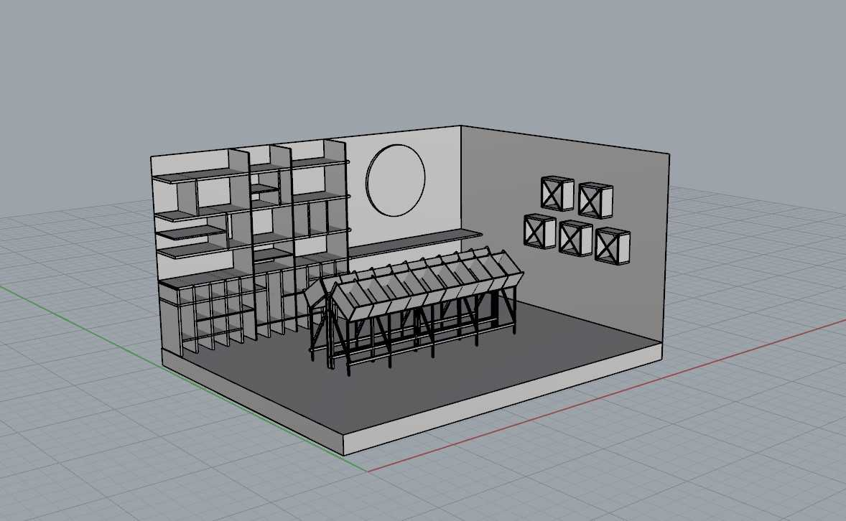

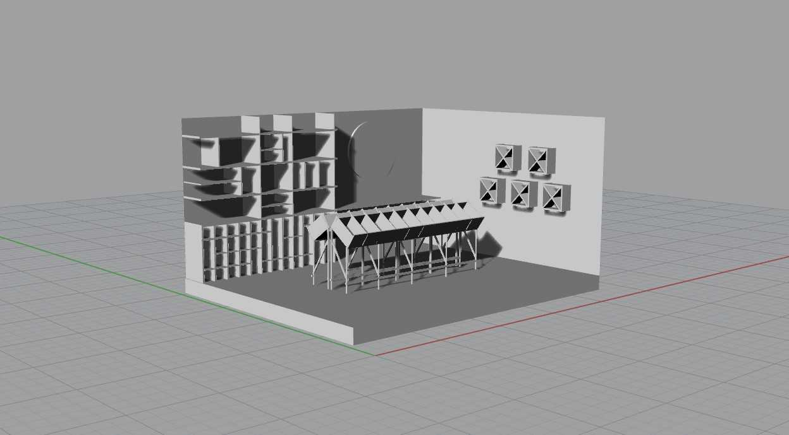

**Exit Strategy**

After our lease expires in the Mizzou Student Center and we achieve our goals of establishing a presence within the university and create solid consumer relationships; we plan to move our physical store to a new space, preferably keeping the location very close to campus. If we have issues finding a physical space, we will focus on our online store and our subscription service. This temporary transition to online-only will involve us starting one-day bicycle shipping the sauces to our online store customers and storing only enough inventory to cover our subscription box service each month. During this time, we will work on fully polishing our online store and marketing the store throughout the nation. Ambitiously, we are combining our online store with machine learning technology to create curated sauce suggestions to each individual registered account within Lost in the Sauce. We plan to begin implementing the machine learning portion of the online store with our Mizzou Student Center opening and improving it throughout the year. If we can move into a physical space, we will continue purchasing inventory, stocking our shelves and developing the online aspect of our business as the main avenue for revenue and growth. In the long-term, we plan to both sponsor and host seasonal sauce competitions where we will offer a bottling contract to winners in exchange for shares of the profits and branded labeling. This will necessitate the use of a commercial kitchen, equipment and experienced employees to be ran successfully. Lost in the Sauce will continue to grow and establish itself as not only a local business but a member of the community. We will then begin the process of franchising our business and expanding into other communities within Missouri and to eventually spread Lost in the Sauce throughout the country. Each store within the Lost in the Sauce franchise will always focus on serving the local market first and ingraining Lost in the Sauce within the community.

**Appendix**

Resumes of Management Team . . . . . . . . . . . . . . . . . . . . . . . . . . . . . . . . Pages 12 - 19

List of Potential Suppliers . . . . . . . . . . . . . . . . . . . . . . . . . . . . . . . . . . . . Pages 20 - 21

Letters of Recommendation . . . . . . . . . . . . . . . . . . . . . . . . . . . . . . . . . . . Pages 22 - 23







­

|  |  |  |  |  |  |
| --- | --- | --- | --- | --- | --- |
| Robert Enyard | | | | | |
| 5 Bismark Pl, St. Louis, MO 63119 | | | | | |
| Cell: 314-482-6353 Home: 314-918-0372 | | | | | |
| rbe731@gmail.com | | | | | |
| Summary | | * Skilled at understanding new concepts quickly, adapting to dynamic situations,   developing solutions from within and outside the box, public speaking   * Intermediate knowledge in MatLab, 2D and 3D CAD, MS Office and Electrical Tech * All-Around Academic Strength in all areas, particularly math and science * Rational and lateral thinker | | | |
| Education | | | **University of Missouri – Columbia** *2015-Present*  **Trinity College Dublin** *2017*  Current Cumulative GPA 3.41/4.00  Pursuing B.S. Mechanical Engineering with Biology and Aerospace Emphases  Major GPA: 3.66/4.00  **Relevant Courses:** Public Speaking, Microeconomics, AutoCAD, Solidworks, Computational Methods for Design  **Webster Groves High School,** *Webster Groves, MO 2011-2015*  Cumulative GPA 4.046/3.857 (w/o weights) | 20 | |
| Educational | | | | | |
| **Achievements** | | * University of Missouri-Columbia Dean’s List High Honor Roll Student *2016-2017* * University of Missouri-Columbia August Honors College Inductee *2015* * Member of Phi Sigma Theta National Honor Society * Awarded Webster Challenge Award for Semester GPA 4.0 or above *2011-2015* * National Society of Black Engineers Scholar *2015* * American Association of Blacks in Energy Scholar *2015* * Recognized in the Statesmen Service Award Program for 180 hours of community service *2012* * National Latin Exam Medal Recipient –Gold *2015*, Silver *2012-2014* * Honor Roll Student *2011-2015* | | |  |
| Community Service and Work Experience  * Physics Tutor at MU Learning Center *2017-Present* - enhanced understanding of physics * Lawn Care at Greater Grace Church *2009-Present* - teamwork and experience with machinery * MLK Jr. day clean up Columbia litter pickup * High School Special Olympics with WGHS * Ameren Safety Fair volunteer - in and outs of handling electrical equipment safely | | | | | |
| Activities & Hobbies | | | | | |
|  | * Mizzou Club Rugby * Botany * Archery * Photo & Video Editing * Crestvale Neighbors Lawn Service (established 2011) * Constructing Mechanical and Electrical devices | | | | |





**Harry Gallagher**

harrygallagher4@gmail.com

Phone: (314) 810-4900

Website: <https://hgal.me>

**GitHub:** harrygallagher4

SKILLS

**SOFTWARE DEVELOPMENT**  JavaScript, Node.js, Java, C

# EXPERIENCE

## LockerDome

**Software Developer** May 2015 - Nov 2015

LockerDome embeds interactive widgets across the world’s top media properties, reaching more than 100 million people per month.

Full-stack web application development with technologies including JavaScript, Node.js and proprietary database software

Programmatically analyzed and reported advertising campaign data

## Gallagher, LLC

**CEO** Jan 2011 - Sep 2014

A self-run company during high school. Provided an application that allowed developers to sell software securely

From-scratch PHP/MySQL application which interfaced with PayPal APIs

Managed product development, customer service and marketing

# VOLUNTEERING

## Jim Schoemehl 5K Run

**Web Developer** Jan 2015 - Jan 2015

The Jim Schoemehl 5K Run raises money to support the ALS Association and a family suffering from ALS

Designed event website

Helped run event

# EDUCATION

## University of Missouri

Aug 2016 - May 2020

Bachelor - Mathematics

**Potential Suppliers**

Local Sauce Suppliers

Local suppliers include all suppliers within both the Columbia and Mizzou area. We are planning to drastically improve this portion of our business once we have a tangible location.

International Sauce Suppliers

International sauce suppliers include all sauces that are not native to the United States. Currently, we have potential suppliers from seven separate countries. Also, included within this list are a few foreign sauces that are produced within the United States.

Regional Sauces

(Cont.)



Regional sauces include all sauces that are native to the United States. These suppliers are based all throughout the country and currently represent more than twenty separate states. The amount of potential regional suppliers for Lost in the Sauce is growing daily.



To Whom It May Concern:

It is with great enthusiasm that I submit this letter of reference for Jack Schroder, Founder/Owner of Lost in the Sauce. I met Jack at 1 Million Cups Columbia and have had the pleasure of visiting with him on several occasions about his Lost in the Sauce business as well as his video production business. I have been consistently impressed with his drive, wisdom beyond his years and entrepreneurial passion.

Jack asked me to review the Lost in the Sauce business proposal. I find the concept exciting and different and feel the brand will easily appeal to the desired millennial customer base. He has put together a team of well-rounded individuals that bring value to the business now and into the future. Not only am I intrigued by the well thought out long-term opportunities of the brand, I look forward to becoming a customer as soon as possible.

The Connection Exchange

204

Peach Way, Ste D

Columbia, MO 65203

573.312.0628



If I can offer any other insight or additional information which may assist you or Mr. Schroder through this process, please do not hesitate at all to get in touch with me.

Best,

Jennifer Schenck

Owner

The Connection Exchange

jennifer@connection-exchange.com

573.514.1389

[www.connection-exchange.com](http://www.connection-exchange.com/)



Department of Political Science

University of Missouri

———————————

Jonathan Krieckhaus, Associate Professor

113 Professional Building • Columbia, Missouri 65211-6030 • Telephone (573) 882-9473 • FAX (573) 884-5131 Email: KrieckhausJ@missouri.edu

Student Unions

University of Missouri

2202 MU Student Center

Columbia, MO 65211

March 1, 2018

Greetings:

I write this letter of recommendation in support of the Lost in the Sauce business proposal by my student, Brian Dugan. I have read it over and it seems like a viable project to me, in that it seems like a plausible product and they make a good case that there is an untapped market. More generally, I am in full support of encouraging my students to pursue their academic and personal endeavors. I hope you give their application your close consideration.

Sincerely,

Jonathan Krieckhaus